**Building Worlds Final Proposal**

**What is it?**

For my thesis I am working on a narrative-driven puzzle game based on the Greek myth of Theseus and the Minotaur. For my final project for this class I want to build one scene from this game.

In the myth, Theseus goes into a maze to kill a half-man half-bull creature called the Minotaur. His lover, Ariadne gives his some string to use to find his way out. My game, tentatively titled *String*, centers on Theseus’s experience of reality. The labyrinth from which he must escape is a manifestation of his guilt over past memories. The narrative itself constructs the maze. That is, the text of the story both contributes to the physical structure of the space and serves as the impetus for the player’s attempt to escape. It is only through manipulating the text that the player can understand her role in the story and be free of the maze.

For this project I will build one room from the maze. The scene I intend to build takes place in a garden where Theseus and Ariadne are having an argument over Theseus’s plan to kill the Minotaur. It is a flashback. The player can move around and interact with the space, but cannot interact with the characters or participate in the dialog. The garden contains a puzzle that the player must solve in order to progress.

**What do I need to figure out?**

The set of the game is minimal. Many of the assets will be in the form of 3D text, which I will build in Maya. Some of this text is deformed or textured to resemble the thing it represents. The characters of Theseus and Adriane will not be animated. They will exist as statues in the garden. When they player interacts with the statues she will hear a section of recorded dialog from the conversation. The garden will contain some procedurally built plant elements, and butterflies that fly around the space.

The eventual game will be played using the Oculus Rift. Ideally, I would like to make this scene compatible with the Oculus as well. This would limit the types of interaction I could use. For example, I could not use mouse input. I could use ray casting from the player camera to determine what the player is looking at and allow her to select and interact with objects using keyboard or controller input.

The scope of this project is fairly large. Since it is related to my thesis I plan to spend additional time on it beyond the usual homework time for this class. I also see the final result for this class as being a prototype for my thesis. It is okay with me if some aspects of the scene remain as stand-ins for the final project as the core interaction works.

**Relate to one or more readings**

This project relates to several of our readings. Most obviously is the reading *10 Print*. Chapter 20 discusses code as a form of maze and talks about the long history of mazes within computer games.[1] The chapter even mentions the myth of Theseus as a touchstone of western thought on mazes.[2] This project can be related to Plato’s “Allegory of the Cave” as well. The Allegory of the Cave deals with the notion of truth in the relationship of object to representation. *String* deals with these concepts as well, playing with the idea of text as an object versus text as meaning. However, my project centers on the individual’s experience and thus takes a more phenomenological approach to understanding truth and meaning.

**Images**

Rough image of what player view might look like

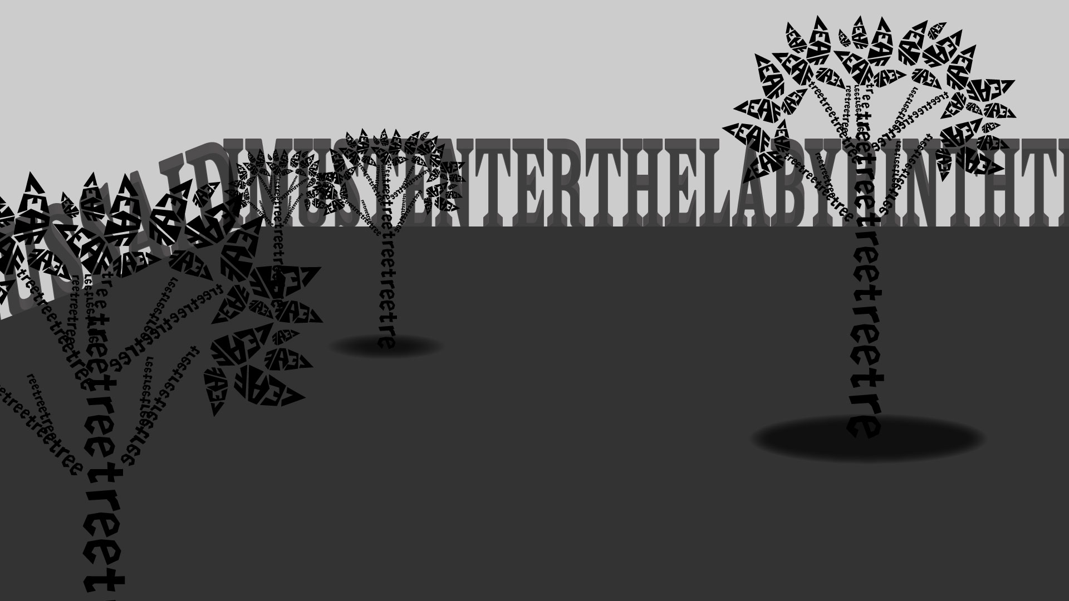

Other examples of text as landscape:

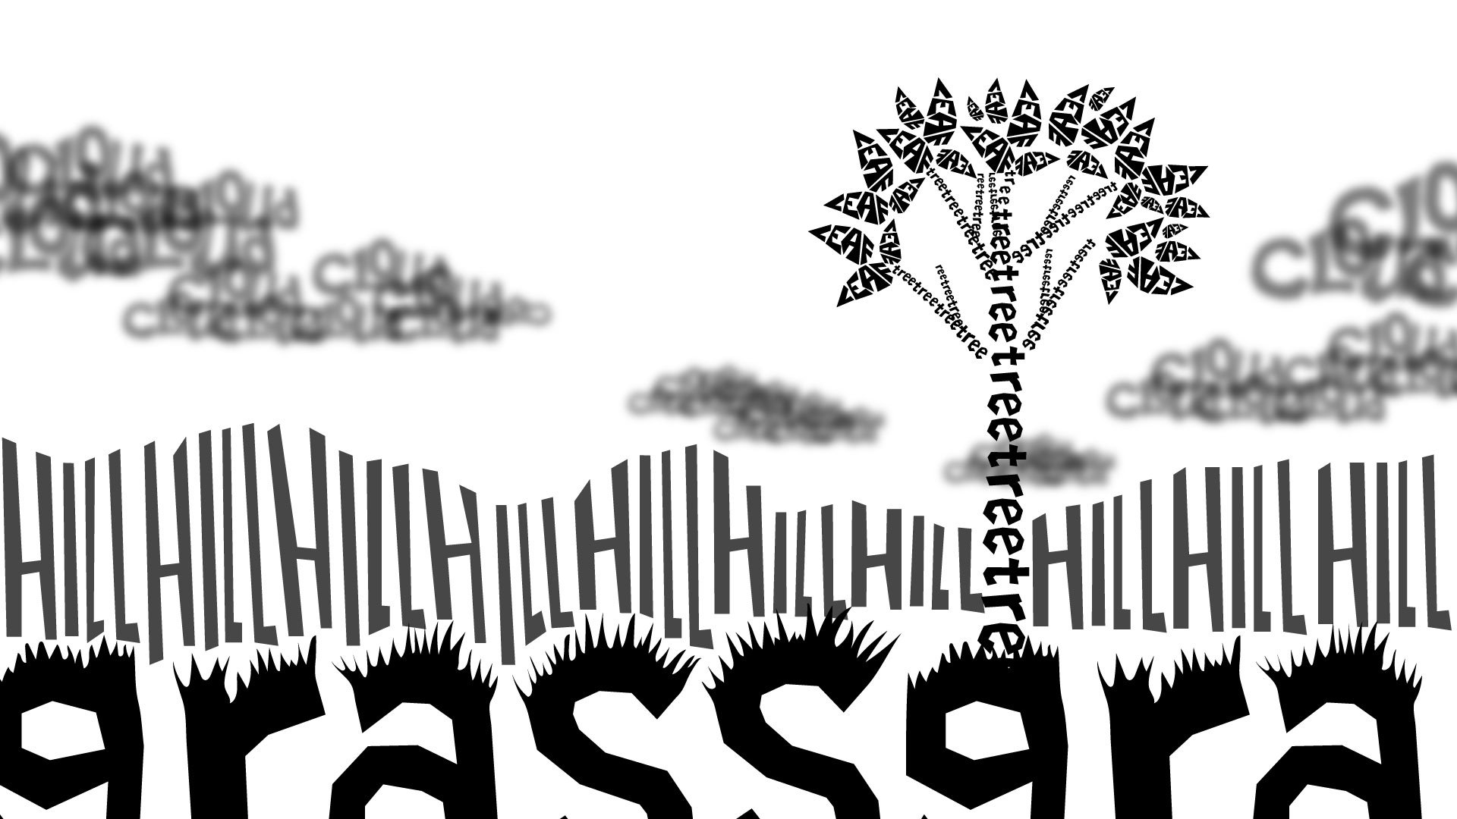

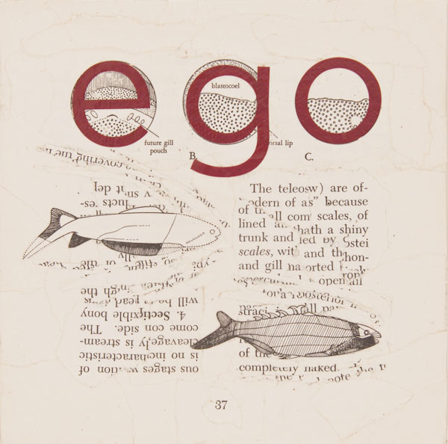

1. 10 Print, 31-51
2. 10 Print, 32